**Create-react-app & hooks: A movie search application**

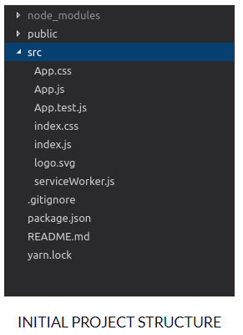

<https://www.freecodecamp.org/news/how-to-build-a-movie-search-app-using-react-hooks-24eb72ddfaf7/>

App.js – the parent component for any React components we create. It will contain major functionality.